5.25: a) At constant speed, the net force is zero, and the magnitude of the applied force must equal the magnitude of the kinetic friction force,
b) 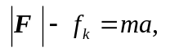so
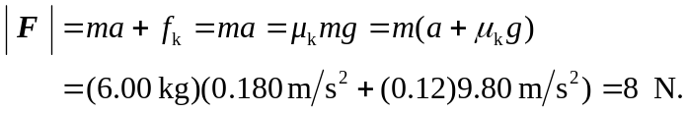
c) Replacing 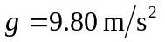 with 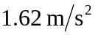 gives 1.2 N and 2.2 N.

